Week 3 – Task 2

Governance Enforcement Flow (Pre-Execution Validation)

1. Overview
This document defines the governance enforcement flow for validating AI actions before execution. The goal is to ensure that all AI-generated actions are evaluated against governance policies prior to execution, reducing risks and maintaining compliance.
The governance layer acts as a control mechanism that validates requests, determines risk levels, and ensures that only approved actions are executed within the system.

2. Governance Enforcement Flow
The governance enforcement process ensures that all AI requests pass through a policy validation stage before execution.
Enforcement Flow
User Prompt
↓
AI Agent Processing
↓
Policy Validation (OPA Policy Engine)
↓
Governance Decision (Allow / Deny / Approval Required)
↓
Action Execution
↓
Audit Logging

Flow Description
- User Prompt
The user submits a prompt or request to the AI system.
- AI Agent Processing
The AI agent interprets the prompt and determines the intended action.
- Policy Validation
The request is sent to the governance policy engine where rules are evaluated.
- Governance Decision
The policy engine determines whether the action should be allowed, denied, or require approval.
- Action Execution
If the policy allows the action, the system executes the operation.
- Audit Logging
The system records the decision and action for governance monitoring and compliance tracking.

3. Policy Validation in Execution Pipeline
Prompt Input
|
v
Agent Planning
|
v
Pre-Execution Policy Validation <-- Governance Check Happens Here
|
v
Action Execution
|
v
Response Generation
Policy validation occurs before action execution to prevent unsafe or non-compliant AI actions. This ensures governance policies are enforced consistently across all AI operations.

4. Validation JSON Schema for Policy Engine Input
{
"input": {
"prompt": "string",
"agent_id": "string",
"action": "string",
"risk_level": "Low | Medium | High | Critical",
"user_role": "string",
"approval": "boolean",
"timestamp": "string"
}
}
This schema defines the metadata sent to the governance policy engine for validation.

5. Alignment with GenAI Metadata Structure
Example AI Metadata
{
"prompt": "Generate financial report",
"agent_id": "finance_agent",
"action": "generate_report",
"risk_level": "Medium",
"user_role": "analyst",
"approval": false,
"timestamp": "2026-03-12T10:30:00Z"
}
The AI agent generates metadata describing the requested action. This metadata is passed to the policy engine for governance validation before execution.

6. Governance Enforcement Workflow
1. User submits a prompt to the AI system.
2. AI agent processes the prompt and determines the intended action.
3. The request is converted into structured metadata.
4. Metadata is sent to the governance policy engine.
5. The policy engine evaluates governance rules.
6. A governance decision is returned (Allow, Deny, Approval Required).
7. If allowed, the action is executed.
8. If approval is required, the request is escalated.
9. If denied, the action is blocked.
10. All decisions are logged for auditing and compliance.

7. Integration Points
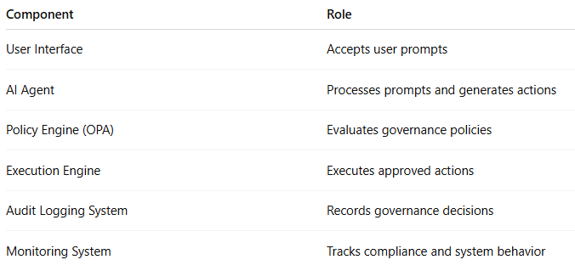

8. Outcome
The governance enforcement framework ensures that AI actions are validated before execution. This structure enforces policy compliance, reduces operational risks, and enables responsible AI usage.
Outcome:
- Governance enforcement flow clearly defined
- Validation schema finalized
- Integration points documented
- Ready for cross-stream discussion

